Legal Services Templates
One-Way NDA and Mutual NDA
These NDA templates are for use in general commercial situations such as discussing a new project or contract with potential suppliers.
If you require an NDA for a different situation then these templates may not be appropriate:
- For any RESEARCH related NDA it is important that you contact RKEC. The page linked contains information on resources including “self-serve” NDA templates and how to refer matters for review. The general contact email for RKEC is rkec@york.ac.uk.
- For any UG PLACEMENT NDA OR A PLACEMENT AGREEMENT CONTAINING CONFIDENTIALITY TERMS please contact legal using the legal-ug-placement-ndas@york.ac.uk address.
If you are unsure of which NDA template you need to use please contact legal@york.ac.uk to seek advice.
Mutual NDA or One-Way NDA?
Use the mutual NDA template if both the University and the prospective partner need to share confidential information eg the University needs to share systems information to obtain new services and the partner may need to set up a demo or release pricing information.
Use the one-way NDA if you only wish to protect University confidential information and the prospective partner will not be sharing sensitive information. The one-way NDA is often used where there is a consultancy-type scenario.
Personal Data
The sharing of personal data is not covered in these standard NDA templates except in a very brief way in case of accidental sharing. If you think that you will need to share any personal data at all please contact dataprotection@york.ac.uk for further advice as potentially you will require a separate data sharing agreement as well as an NDA or a bespoke NDA with data protection provisions.
Other scenarios where these agreements may not be suitable:
- You intend to share a very large data set or commercially very sensitive data
- You are dealing with a company or institution based overseas
- You are exploring software development
In all these scenarios please contact legal@york.ac.uk to discuss bespoke terms
Drafting the NDA
The areas requiring input from you are highlighted in yellow eg:
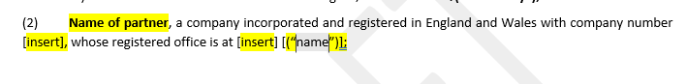
Where there are square brackets this indicates that you will need to add or amend wording eg “whose registered office is at [insert]”.
In section A of the background you will need to add a description of the “Purpose”. This is the reason why you need to share confidential information with the other party. It doesn’t have to be very “legal”, just a straightforward explanation of the particular deal For example:
“A. the Parties intend to enter into discussions relating to the purchase of whiteboards and smartboards by the University from the Partner (“Purpose”) which will involve the exchange of Confidential Information between them”.

Other points:
Make sure the parties are clearly identified with their legal name rather than trading name. If they use a trading name you can include this eg “Big Catering Company Limited, trading as Caterco, a company incorporated in England and Wales with company number 123456 whose registered office is at 1, Commercial Way, Industrial Estate, Liverpool, (“Big Catering Co.”)
N.B the bit in brackets and in speech marks indicates a definition to make it easier to refer to the partner throughout the document, so you don’t have to write out “Big Catering Company Limited” each time you need to refer to the partner. You will see lots of these definitions throughout the NDA eg ““Agreement” means this confidentiality agreement.”
Review the NDA from time to time. If the relationship has evolved into something different eg the partner may be offering additional services or taking on a different role, make sure you check to see that the “Purpose” covers this. If it doesn’t then you may need a new NDA or an addendum to the existing NDA.
If you go on to enter into contract with the partner then the terms of the agreement will take precedence so again, if you wish to discuss some other project/service with the partner make sure you check to see if you need a new NDA.
If the partner proposes amendments to the NDA, particularly eg a different choice of law and jurisdiction (eg law of the State of Florida and Florida Courts to have jurisdiction) then refer it to Legal for further review of the proposed changes.

Getting the NDA signed
When you and the partner are happy with the NDA (ensure this is confirmed with them) prepare a version for signing which has any yellow highlights and square brackets removed and the “DRAFT” watermark removed. Remove any comments in the document, particularly any comments for internal view only.
You can then arrange for signature. The person who can sign for the University will be listed in the University Contract Framework Document in appendix 4. The list for NDA’s is as follows:
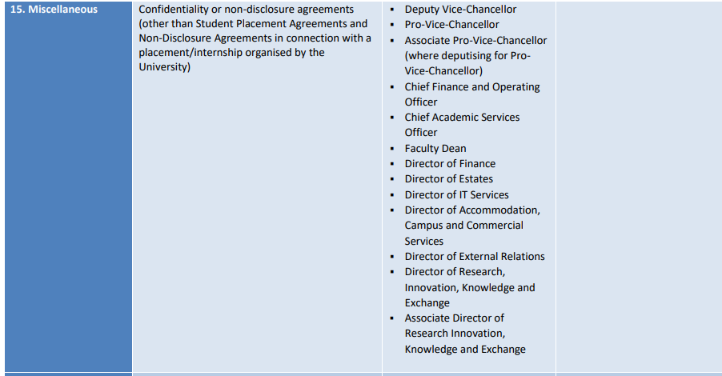

Please check the document itself rather than relying on this as there may be changes made from time to time.

If you have any questions at all or would like any help in drafting your NDA please contact legal@york.ac.uk.

